Steps for Registration under the Delhi VAT Act
Steps for Registration under the Delhi VAT Act- Guidelines

1. First of all, the dealer have to go to the official website of Delhi VAT by using following domain, i.e.,www.dvat.gov.in

2. Then click on the link of “New Registration” available on the left side of the page.

3. After that, the dealer have to submit some basic details for PAN verification from NSDL, such as, Name of the Firm/Company, Constitution, PAN, Aadhaar No. and Contact details online.

4. On successful PAN verification, the dealer will be provided Username and password through e-mail for
further process.

5. The dealer would login and fills up registration forms, i.e., for Local “DVAT-04” & for Central “Form-A” in which dealer have to submit details as mentioned below: -

- a. Address of principal place of business;
- b. Any additional place of business;
- c. Bank details;
- d. Particulars of persons involved in the Firm/Company;
- e. List of Goods to be dealt in along with goods required for packing; etc.

6. And upload supporting documents such as ownership proof/rent agreement/NOC of landlord/electricity bill/telephone bill, address proof, identification proof, etc.

7. The size of respective documents should be less than 100 KB each in the format of pdf/jpeg.

8. If the size of documents gets greater than 100 KB, then the dealer can use various softwares, such as, Microsoft Office picture manager, Photoshop, Coreldraw, etc. to reduce the size to 100 KB or less.

9. Then go to the link of submission to submit the registration application with VAT department.

10. After submitting, the dealer will receive one e-mail consisting of temporary TIN and password which can
be used for further transactions.

11. The Court fee of Rs. 1,025/- (w.e.f. 17.6.2014) for new registration will be submitted online.

12. After the whole procedure is approved by the VATI, the dealer can take out the print of online generated Registration Certificate and need not to go to Trade & Taxes Department.

STEP 1 – First of all visit website of DVAT Department using following URL.
http://dvat.gov.in/website/home.html
Then go to New Registration Segment.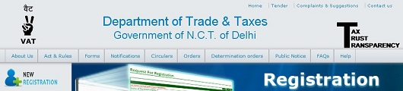
STEP2 – Fill this form very carefully which you will get after you click on NEW REGISTRATION.
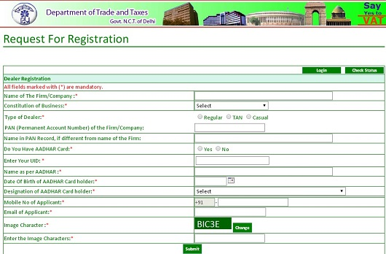
Whose Moto is to get the information of Proprietor/Partner/Authorised Signatory
For their respective PAN verification by the department.
After submitting this form you will receive first confirmation mail from Helpdesk DVAT.
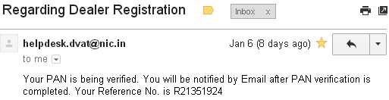
STEP 3 – Now your PAN verification may took 1-4 days and after which you will receive second confirmation mail from Help desk DVAT.
STEP 4 – Again visit site using first URL and go to Dealer login segment.
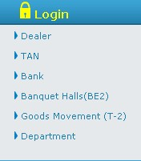
Use Reference no as User ID and Mobile No as password that you have received in second confirmation in Step 3.
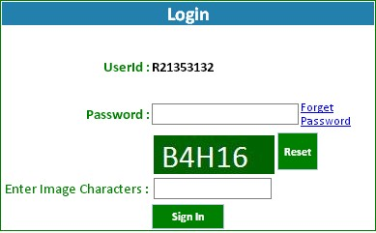
Now it require you to change your existing password (which was your mobile number) to new password.
STEP 5 – Then you need to start fill registration form ; for which go to Part A of DVAT 4 Segment and fill and save it wisely.
Similar process shall be done for Part B ,Part C & Part D.
STEP 6 – Go to CST —- segment and fill Form —- only if you want to register your dealer for CST also.
STEP 7 – Upload the scanned requisite documents in PDF Format.
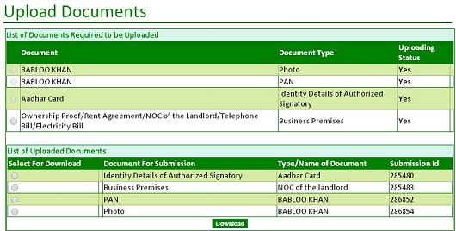
STEP 8 – Now it is the time for you to make payment of Court Fee either through online mode or offline mode.
Rs.1000 for VAT REGISTRATION
Rs.1000 + Rs.25 for VAT + CST REGISTRATION
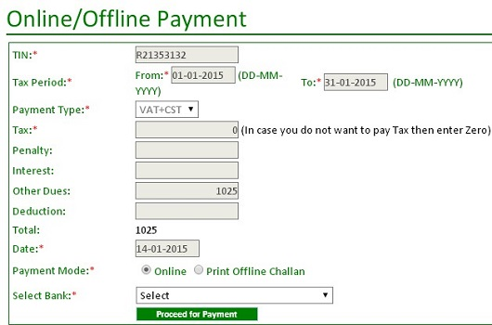
If you choose to make payment through online mode then you can see your payment record here only but it may take 1-2 days and until it reflect here as paid ,further process is not possible.
STEP 9 – Go to submit section and submit it.
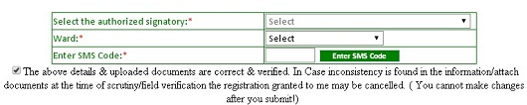
STEP 10 – Take print out.

How To Apply For A TIN Number
What is a TIN? Tax Information Network (TIN) is an initiative made by Income Tax Department of India to modernize the current system for collection, processing, monitoring and accounting of direct taxes using information technology. It is a repository of Tax related information from across the country. It is unique registration eleven digit number that is used for identification of dealers registered under VAT.
Who should register for TIN? TIN number registration is required for Manufacturers, Traders, Exporters and Dealers. When new registration is undertaken under VAT or Central Sales Tax a new TIN will be allotted under registration number. The TIN number should appear on all Quotations/Orders/Invoices by both Sending Company and Receiving Company.
What is the procedure of TIN registration?
You can apply for this number online or visit one of the governments many facilitation centres across the country and submit this form.
Visit this link to find the one closest to you.
These are the documents that you will need to apply for a TIN number
1. ID Proof / Address proof / PAN card of proprietor with six photographs
2. Address proof of Business premises
3. 1st Sale / Purchase Invoice, copy of LR/GR & payment/collection proof with bank statement
4. Surety/Security/Reference.
This may differ slightly from State to State. After these documents are checked and scrutinized, a unique TIN number is provided to applicant. For applicants who have Central Sales Tax number, this can be changed to TIN number on request by the tax department.

